*AN AWARD WINNER INTERNATIONAL ORGANIZATION*

a Im



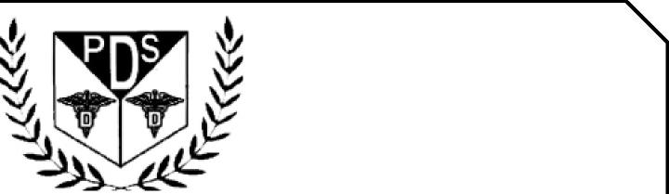

PROMOTING EXCELLENCE IN DENTAL EDUCATION   
Over 7000 Members Strong

**Presents**

A Must attend seminar for you and your staff

**ONLINE WEBINAR**



**On   
APRIL 27TH, 2025 (Sunday) 8:00am till 10:00am   
(CA Board 2 hrs C.E. units)   
at**

COSMETIC DENTISTRY **BY** DR. NADER YERMIAN

(Please print in capital letters or attach your business card)

Name DR/RDH/RDA/DA____________________________ Lic no

|  |  |  |  |
| --- | --- | --- | --- |
| Circle one First Middle Initial Last | |  |  |
| Address |  |  |  |

City State Zip

Cell no _____________________________ E-Mail_______________________________________________

**ARE YOU A PDS MEMBER: YES/ NO**

|  |  |  |
| --- | --- | --- |
| REGISTRATION FEE |  |  |
| Dentists Non-members | $50.00 |  |
| Members | $40.00 |  |
| Hygienist/R.D.A. Non-members | $40.00 |  |
| Members | $35.00 |  |

FOR REGISTRATION

CALL TOLL FREE 1-866-422-5573 (1-866-4-CALL-PDS) OR 909-933-9076   
**TO REGISTER ONLINE VISIT US ON WWW** [**PDSOCIETY. COM**](http://PDSOCIETY.COM)

Make check payable to

Dr. R. Salwan

President



PDS

124 EAST F STREET SUITE #8 ONTARIO, CA 91764

Dr. D.P. Singh Nagra

Chairman



**Webinar Date & Time:**

Sunday, April 27th, 2025, 8:00 AM - 10.00 PM Pacific Time (US & Canada)

**Duration: 4 Hours**

**Presenter:**

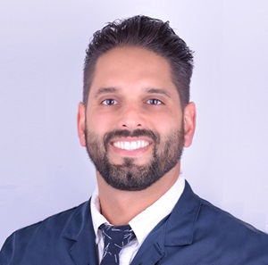

DR. NADER YERMIAN

Dr. Nader Yermian received his Doctorate of Dental Surgery (D.D.S.) degree from USC School of Dentistry. While at USC School of Dentistry, Dr. Yermian completed an 18-month Esthetic Selective program taught by Dr. Pascal Magne, and was awarded the highest honor in the program - the Charles L. Pincus Award for outstanding achievements in esthetic dentistry by the American Academy of Esthetic Dentistry. Dr. Yermian was also the recipient of the Scholastic Achievement Award from Psi Omega Dental Fraternity. Upon receiving his D.D.S. degree, Dr. Yermian completed a General Practice Residency at Montefiore Hospital in New York City. As an experienced practitioner, Dr. Yermian uses a "biomimetic" approaching in restoring damaged teeth to mimic the function, strength, and beauty of natural teeth.

**Innovative Biomimetic Approaches to Injectable Composite**

LEARNING OBJECTIVES

* Learning the versatility of Composite-Resin Injectibles
* Straight case vs multi-layered
* Design/3D-Printing
* Matrix Guide Fabrication
* Isolation Techniques
* Combination Cases with Porcelain Veneers
* Posterior Teeth and Build-Up Techniques
* Porcelain Cementation with Injectables
* Armamentarium Essentials

Composite resin injectables are highly versatile materials that can be used in numerous scenarios to enhance cosmetic dental practices in a minimally invasive manner, while also facilitating everyday general dentistry. Mastery of composite dentistry, understanding proper adhesive protocols, and establishing effective isolation techniques are crucial steps toward gaining confidence in the functional outcomes of these restorations.

In this webinar, our goal is to educate participants on how to confidently place predictable composite injectable restorations in both the esthetic zone and posterior teeth. We will cover various case types, including the increasingly popular fiber injectable composites used for build­up procedures. Additionally, we will provide an overview of the cementation protocols for indirect porcelain restorations using injectable materials

THIS WEBINAR IS SPONSORED BY GC AMERICA AND PUNJABI DENTAL SOCIETY